Name (School, District, or Organization)
Street Address
Town, State 00000

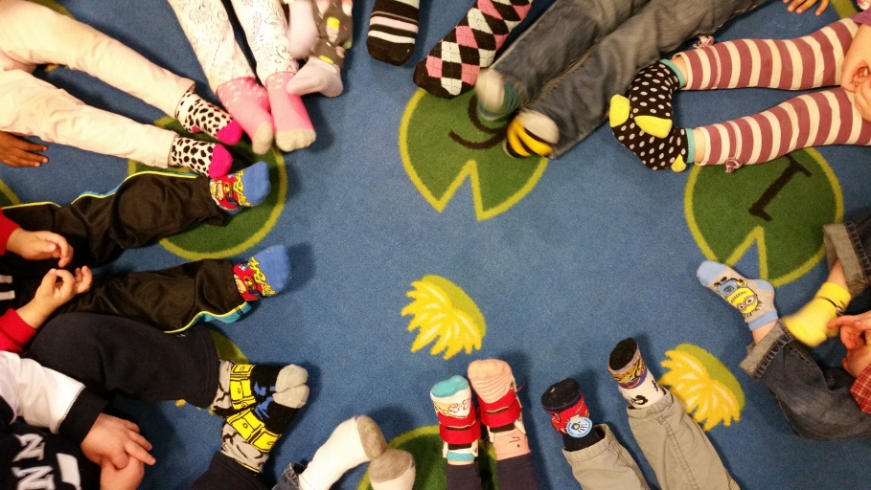

Dear (School Name, District, or Organization) Families,

World Down Syndrome Day is observed on March 21st to raise awareness and understanding of Down syndrome (a congenital disorder caused by an extra copy of the 21st chromosome also called Trisomy 21). 3:21 represents the third copy of the 21st chromosome. This year we would like to raise awareness, understanding, and acceptance of Down syndrome by participating in “Rock Your Socks.” When individuals with Down Syndrome and other disabilities are given the opportunity to participate, all individuals involved benefit from an inclusive environment with friendships, acceptance, respect for all, and positive expectations.

For a suggested donation of $1.00, students, teachers, and staff can wear silly socks, mismatched socks, brightly colored socks, long socks, short socks, printed socks, 1 sock, and even 3 socks for 3 chromosomes. If someone does not normally wear socks then they might consider wearing them. Why stop at socks? Break out the brightly colored clothing or blue and yellow if you like. The choice is yours.

We ask that on March 21st, you join us in wearing something that people will ask you about so that you can tell them about raising awareness, understanding, and acceptance for Down syndrome. The money raised from the donations will be sent to the Down Syndrome Association of Connecticut.

Thank you in advance for helping to make this event a great one! This is a cause that many families and friends in (School Name, School District Name, or organization) are very passionate about.

Sincerely,

(School Name, School District Name, or Organization)

